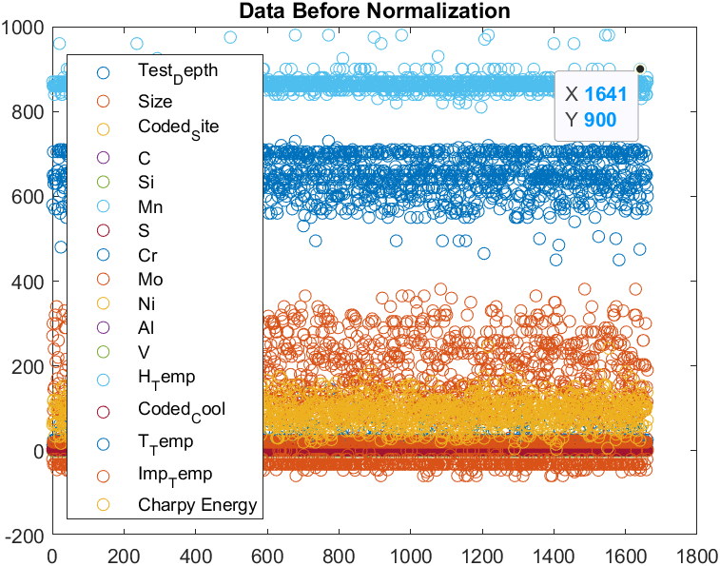

This graph is showing the distribution of input values before normalization

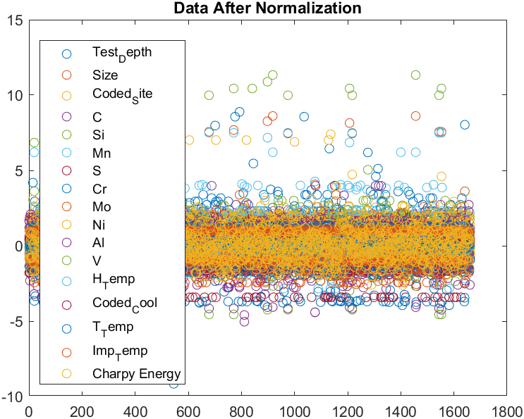

This graph is showing the distribution of input values after normalization

T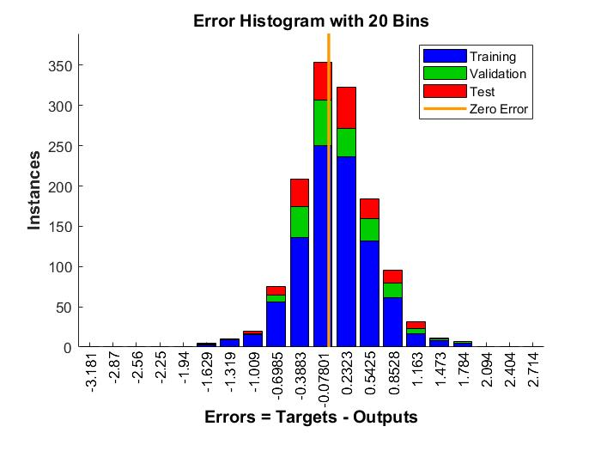

This graph is showing the errors and no of occurance of a specific values

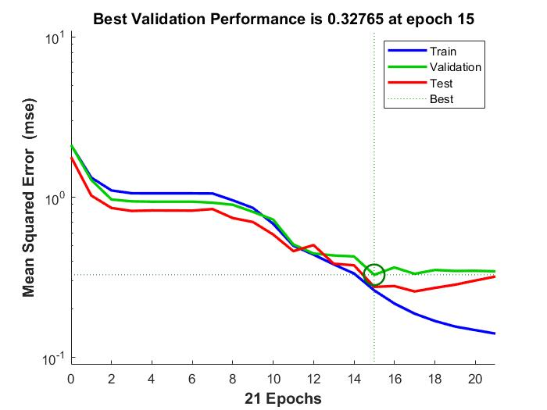

Thisgraph is showng that we have total 21 epochs used and from which we have lowest MSE at epoch no 15 which was 0.32, learning curves for training validation and testing are shown in graphs by blue, green and red respectively.

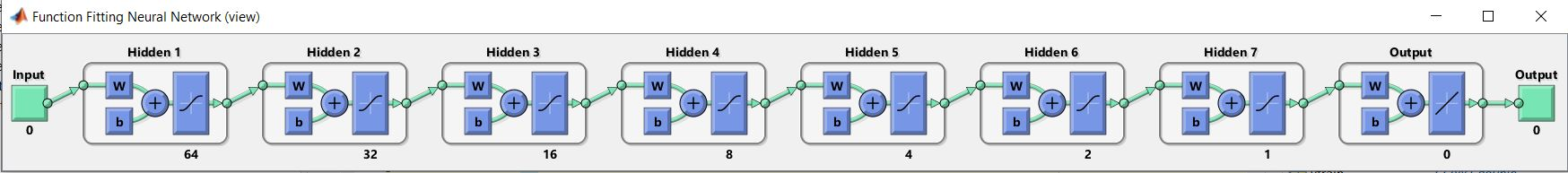

This is the Multi Layer Perceptron (MLP) Network used for Regression Problem.

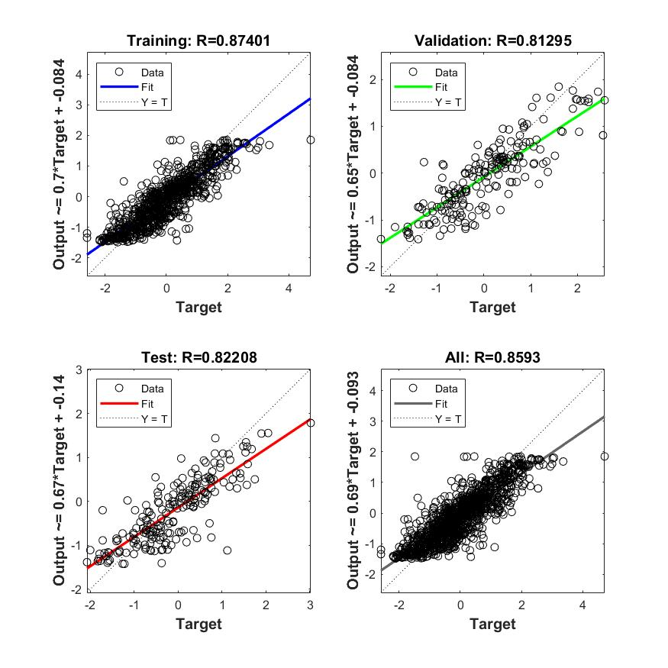

This graph is showing the results for line fitting for training, validation and testing of MLP.

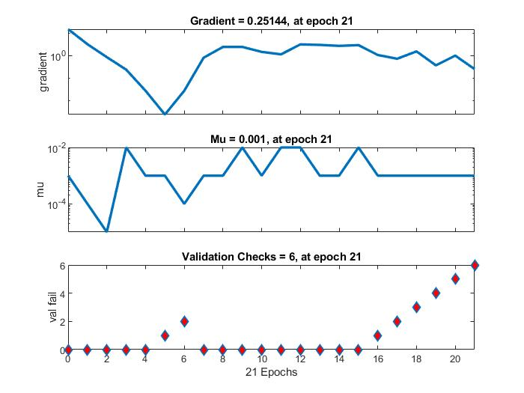This graph is showing the results of gradient, mu, and val fail for each epoch.